TC-PM-006
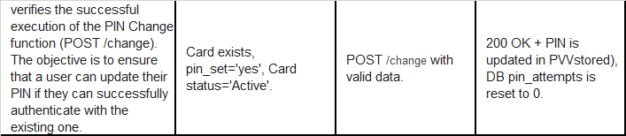
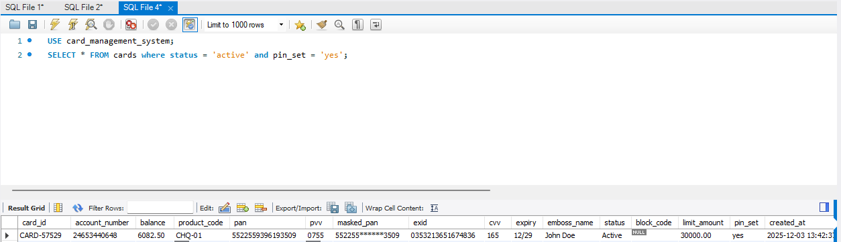
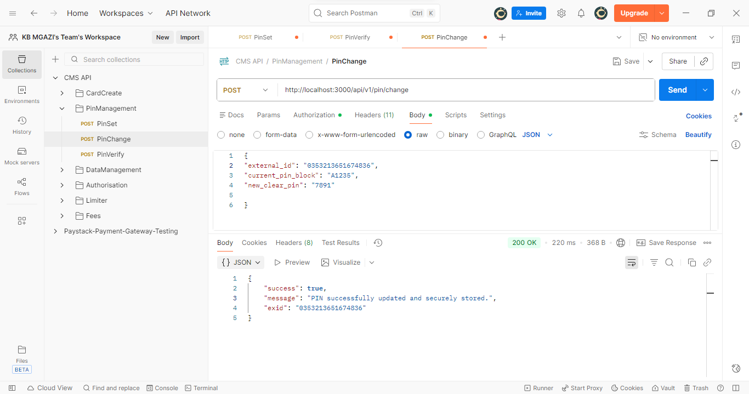
Request:
{
"external_id": "0353213651674836",
"current_pin_block": "A1235",
"new_clear_pin": "7891"

}
Response:
{
"success": true,
"message": "PIN successfully updated and securely stored.",
"exid": "0353213651674836"
}

